EXAM-I TOPICS FOR DISCUSSION

- Exam format:
  - Objective questions – T/F, Multiple Choice, Fill In the Blank, etc.
  - No writing of R code
  - Approximately 40 questions –
  - Exposed on Friday nite or Sat Morning and closes on Wednesday midnight.
  - Must be entirely your own work
  - Only ONE submission.
- Topics Covered: Chapter 1 thru Chapter 4
- Review Topics;
  - Chapter 1: Data Basics
    - Descriptive vs inferential statistics
    - Population, samples, randomness & random variables,
    - Random sampling
    - types of variables – numerical categorical continuous, discrete ordinal, rank
    - independent vs dependent variables, response vs explanatory variables
    - association of variables, correlated vs causal relationship
    - scatter plot vs histograms vs bar charts vs Box Plots
    - Central tendencies – Mean, Median, Mode, Descriptions and resistance to extreme values
    - Box Plot - pth Percentiles, Quartiles. Percentiles and IQR, identify outliers
    - Dispersion/Measures of Spread – Variance, Standard Deviation, Range & Properties of Standard Deviation
    - Shape of Distributions – Symmetrical, left skewed, right skewed.
    - Experimental Designs: Placebo, Placebo effect, Blinding, Double Blinding
    - Random sampling techniques: simple, stratified, and cluster sampling.
  - Chapter 2: Probabilities
    - Random process
    - Law of large numbers
    - Disjointed (Mutually Exclusive) or Non Disjointed Outcome
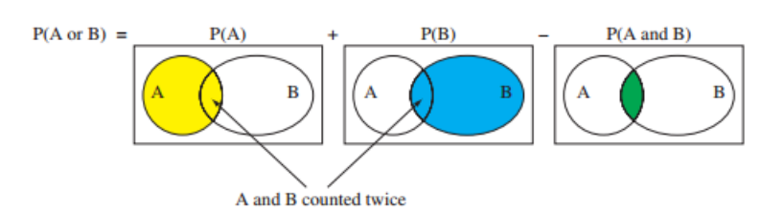
For the union of two events P(A or B) = P(A) + P(B) – P(A and B). If disjoint, P(A and B) = 0, so P(A or B) = P(A) + P(B)
Example: What is the probability that a randomly sampled student thinks marijuana should be legalized or they agree with their parents' political views?
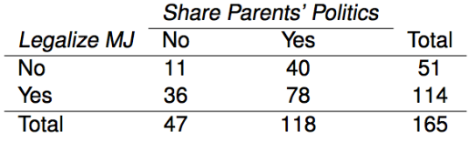
(a) (40 + 36 - 78) / 165
(b) (114 + 118 - 78) / 165
(c) 78 / 165
(d) 78 / 188
(e) 11 / 47
    - Probability of events occurring when sampling with Replacement vs Without Replacement.
    - For Example:
In most card games cards are dealt without replacement. What is the probability of being dealt an ace and then a 3? Choose the closest answer.
(a) 0.0045
(b) 0.0059
(c) 0.0060
(d) 0.1553

    - Roughly 20% of undergraduates at a university are vegetarian or vegan. What is the probability that, among a random sample of 3 undergraduates, at least one is vegetarian or vegan?
(a) 1 - 0.2 x 3
(b) 1 - 0.23
(c) 0.83
(d) 1 - 0.8 x 3
(e) 1 - 0.83

    - Conditional Probability - Inverting Probabilities, Bayes Theorem – Next Exam
  - Chapter 3: Probability Distributions
    - Normal Distribution and Z statistic

Body temperatures of healthy humans are distributed nearly normally with mean 98.2oF and standard deviation 0.73oF. What is the cutoff for the highest 10% of human body temperatures?
A. 97.3 F C. 99.4 F
B. 99.1 F D. 99.6 F
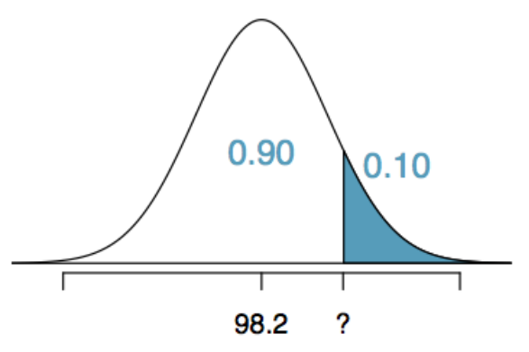
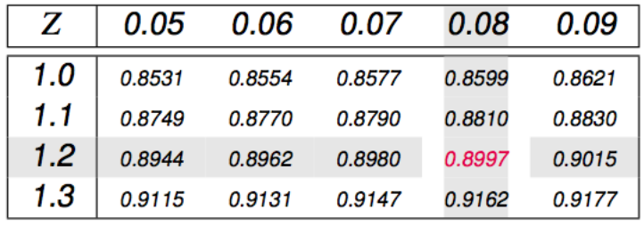
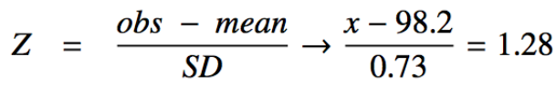
___________________________________________________
Can we calculate the probability of rolling a 6 for the first time on the 6th roll of a die using the geometric distribution? Note that what was a success (rolling a 6) and what was a failure (not rolling a 6) are clearly defined and one or the other must happen for each trial.
1. no, on the roll of a die there are more than 2 possible outcomes
2. yes, why not
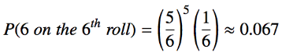
__________________________________________________________________________
A 2012 Gallup survey suggests that 26.2% of Americans are obese. Among a random sample of 10 Americans, what is the probability that exactly 8 are obese?
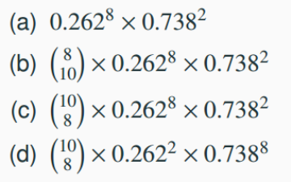

An August 2012 Gallup poll suggests that 13% of Americans think home schooling provides an excellent education for children. Would a random sample of 1,000 Americans where only 100 share this opinion be considered unusual? A. Yes B. No
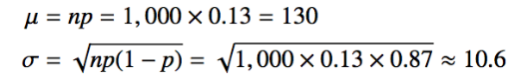

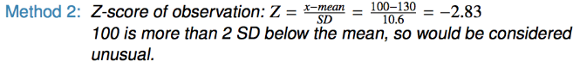

Below are four pairs of Binomial distribution parameters. Which distribution can be approximated by the normal distribution?
A. n = 100, p = 0.95
B. n = 25, p = 0.45
C. n = 150, p = 0.05
D. n = 500, p = 0.015

What is the probability that the average Facebook user with 245 friends has 70 or more friends who would be considered power users?

We are given that n = 245, p = 0.25, and we are asked for the probability P(K ≥70). To proceed, we need independence, which we'll assume but could check if we had access to more Facebook data. (Can we assume a normal distribution??)

Mean = np stdev = sqrt( np(1-p))

P(X ≥ 70) = P(K = 70 or K = 71 or K = 72 or … or K = 245)
= P(K = 70) + P(K = 71) + P(K = 72) + … + P(K = 245)

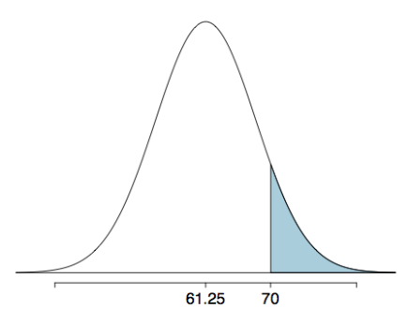
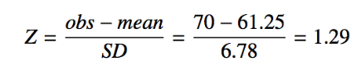
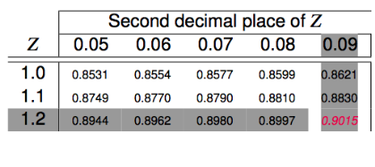
  - Chapter 4: Foundations for Inference
    - Point estimate vs interval estimate
    - Central Limit Theorem –
    - The distribution of the sample mean is well approximated by a normal model
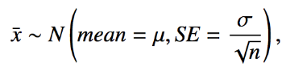
      - SE = standard error. Use s since σ is unknown
      - sampling distribution we saw earlier was symmetric, and centered at the true population mean.
      - SE = σ / √n, Note that as n increases SE decreases hence the variability among the sample means would be lower.
    - Confidence Intervals: Defined as: Point Estimate ± z*x SE
for 95% CI, Z is approx. = 2
    - What does 95% confident mean? If you built 100 intervals with above formula, the 95% of them would contain the true population mean
    - In a confidence interval, z* x SE is called the margin of error, and for a given sample, the margin of error changes as the confidence level changes or Sample size
    - Use tables to set z values for appropriate Confidence percentage
  - Chapter 4: Hypothesis Testing:
    - Number of College Application Example (pg 21-26)
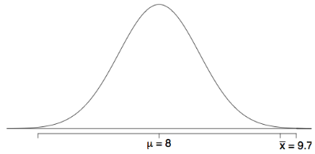
    - One sided vs two sided Hypothesis Testing
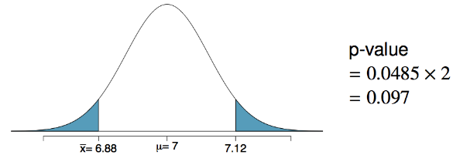
Decision Error
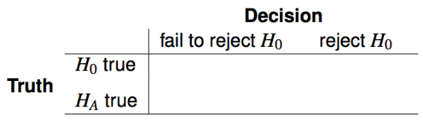 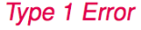
We (almost) never know if H₀ or H_{a} is true, but we need to consider all possibilities

Recap: Hypothesis testing for a population mean

1. Set the hypotheses
●H0: μ = null value
●HA: μ < or > or ≠ null value

2. Calculate the point estimate - xbar

3. Check assumptions and conditions
●Independence: random sample/assignment, 10% condition when sampling without replacement
●Normality: nearly normal population or n ≥ 30, no extreme skew -- or use the t distribution (Ch
4. Calculate a test statistic and a p-value (draw a picture!)

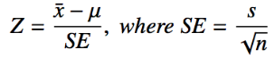

5. Make a decision, and interpret it in context
●If p-value < α, reject H0, data provide evidence for HA
●If p-value > α, do not reject H0, data do not provide evidence for HA
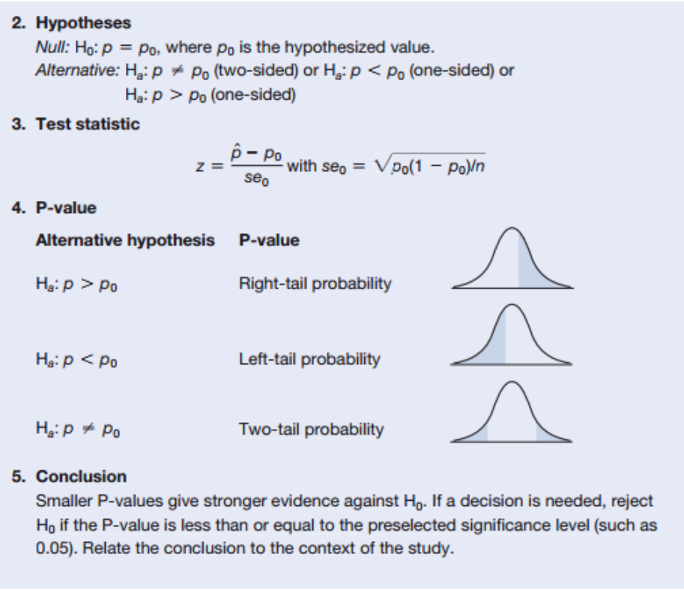
__________________________________________________________________
Finding a sample size for a certain margin of error
A group of researchers wants to test the possible effect of an epilepsy medication taken by pregnant mothers on the cognitive development of their children. As evidence, they want to estimate the IQ scores of three-year-old children born to mothers who were on this particular medication during pregnancy. Previous studies suggest that the standard deviation of IQ scores of three-year-old children is 18 points. How many such children should the researchers sample in order to obtain a 96% confidence interval with a margin of error less than or equal to 4 points?

Not: Confidence Interval is Defined as: Point Estimate ± z*x SE
So we need to fine n which gives us 4 >= z*x SE for a critical value of 96% CI
We know that the critical value associated with the 96% confidence level: z* = 2.05.

The minimum number of children sample required to attain the desired margin of error is 85.1. Since we can't sample 0.1 of a child, we must sample at least 86 children (round up, since rounding down to 85 would yield a slightly larger margin of error than desired).

